An Inspector Calls Social and Historical Context Questions
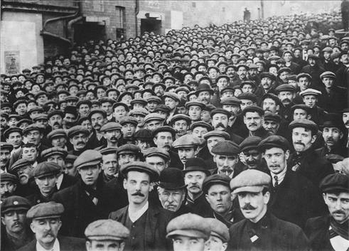To complete the following questions, you will need to use information from the film on the social and historical context of the play, your timeline, and your hand out.
The Edwardian Era
- What hardships did poor people face in their lives and work in the years before WW1?

- Select key events from the years 1910 to 1914 that illustrate what life was like for the poor.

- What additional difficulties did working class women face in the years before WW1?
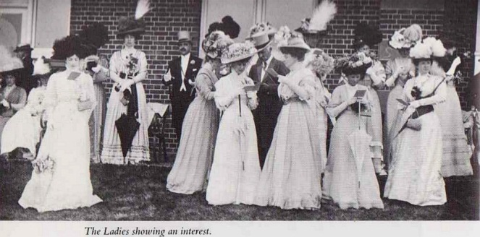
- In contrast, what was life like for upper class men in the years before WW1?

- 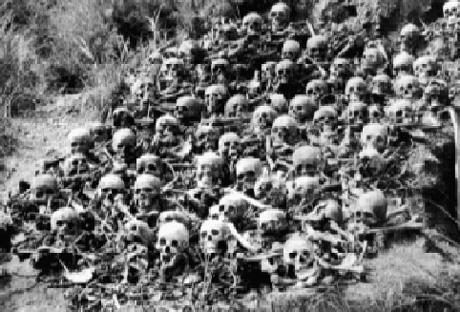What was life like for upper class women in the years before WW1?

After WW2

- After WW2, how had the class system changed, and why?

- 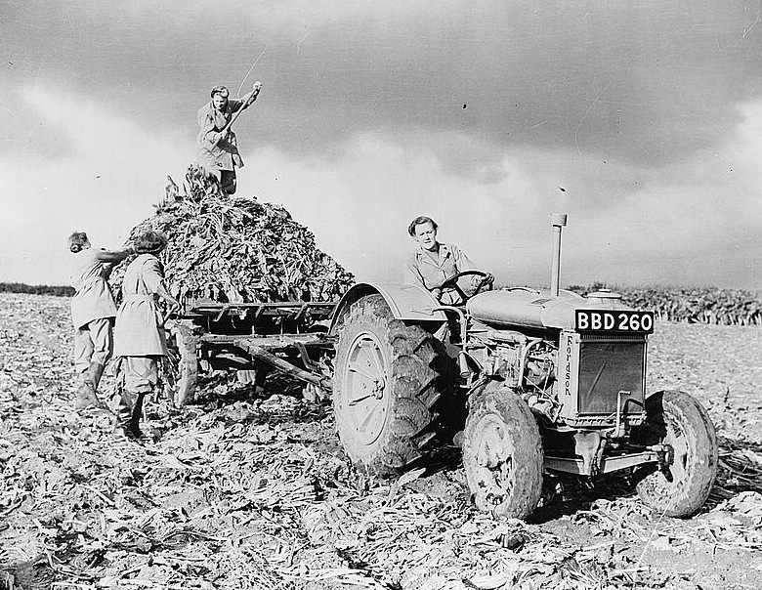After WW2, how had people’s political views changed, and why?

- After WW2, how had the status of women changed, and why?

J B Priestley

- 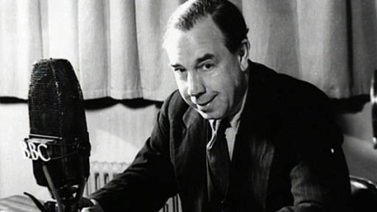Summarise J P Priestley’s ideas and views about society.

- Why did Priestley set the play in 1912? What effect did he hope that it would have on an audience in 1946?

