Analysing a Newspaper Report
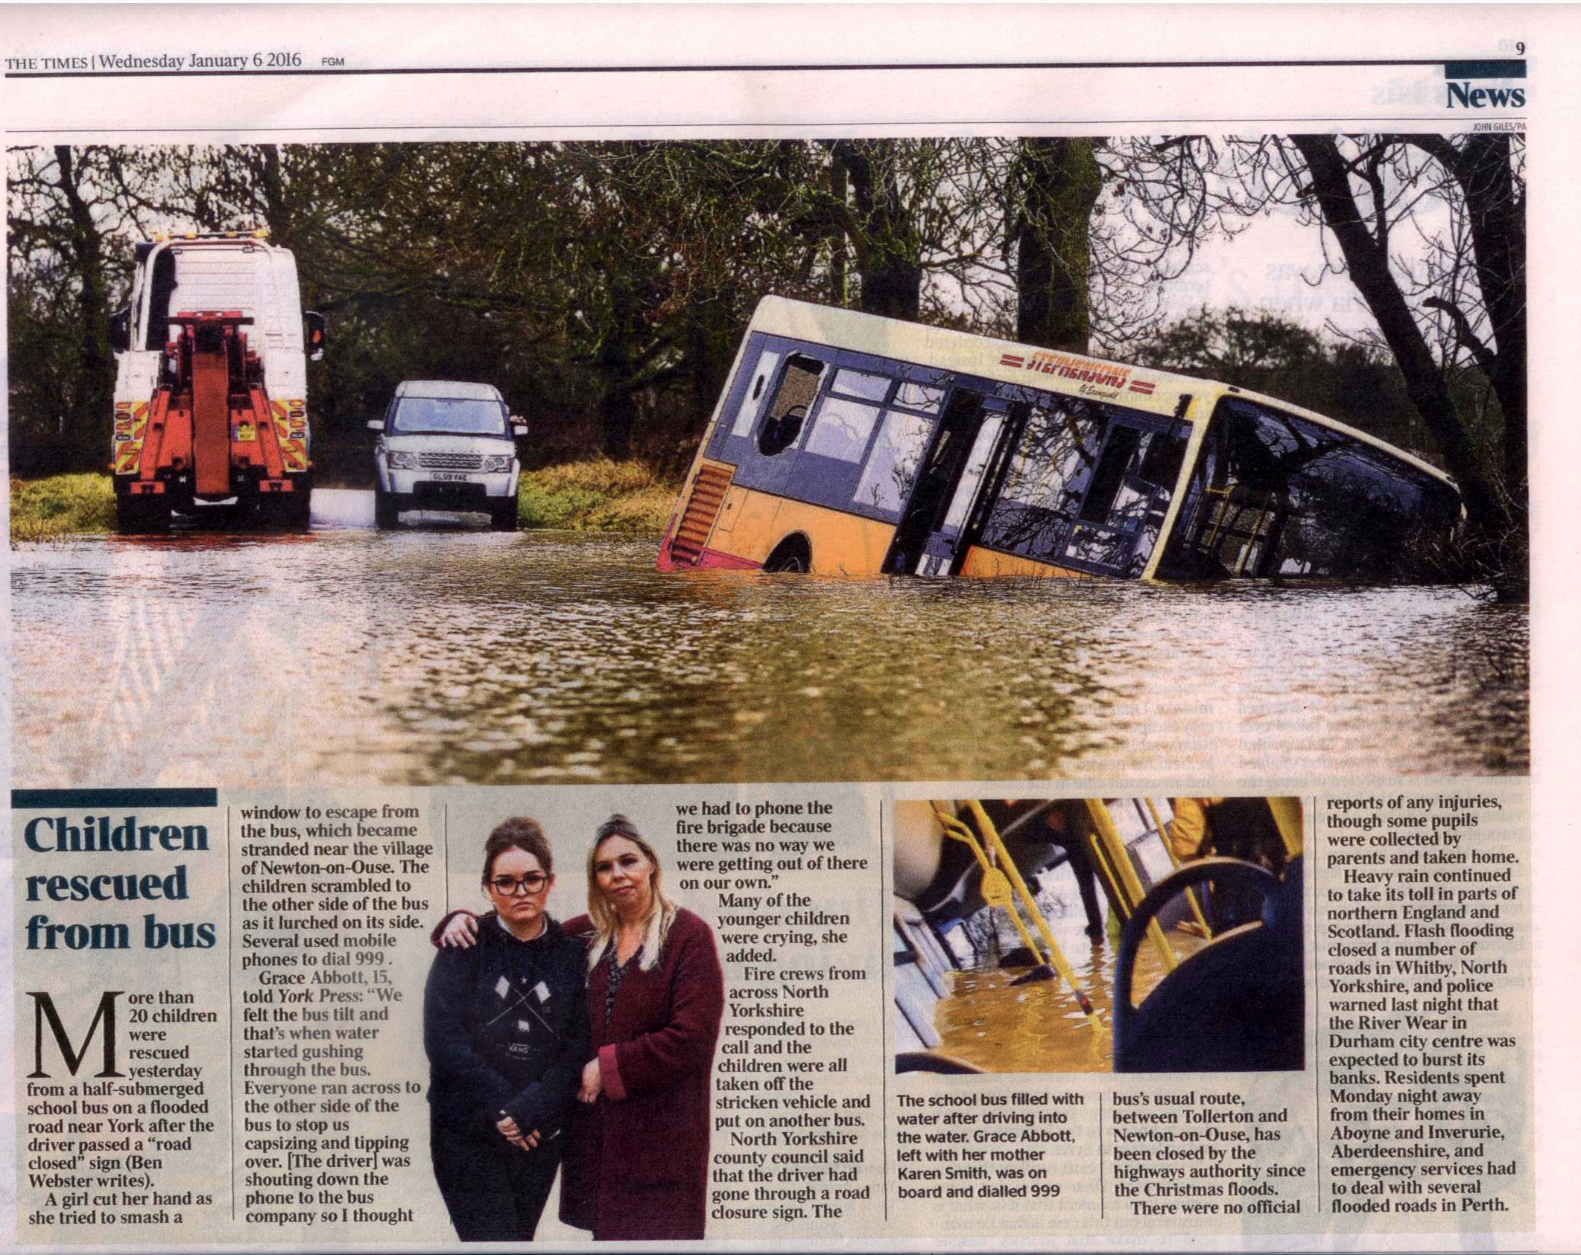
What?

Who?

Where?

When?

Why?

Brief summary of incident:

