CURLEYS’

# General information

# She is newly married to Curley, the son of the boss.

* She is young, pretty, and cares about her appearance.
* Lennie describes her as “Purty”

# We never know her name – she is merely Curley’s ‘property’ with no individual identity.

# She comes across as very flirtatious women and seeks the attention of the men on the ranch. She is always finding excuses to hang around the bunkhouse. She dresses inappropriately, over-made up, with her red lipstick and ostrich feathers showing how she doesn’t fit in on the ranch

# If the men flirt back there will be serious consequences – Curley always wants a fight.

# She wears a lot of red – her lips are “roughed” and her fingernails and shoes are red, symbolizing danger and sex.

# She had a failed dream of being a star in Hollywood.

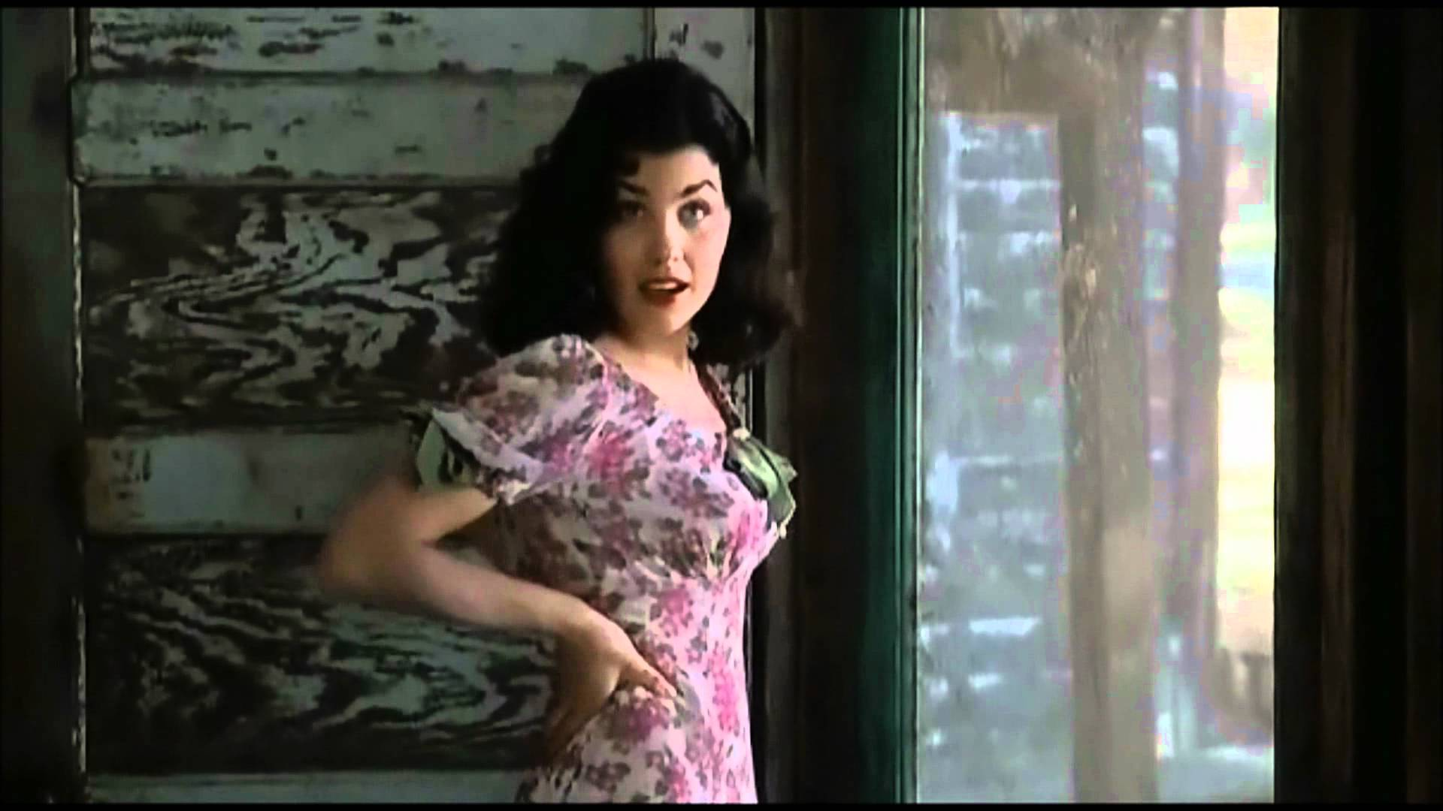

Quotations

She flirts with all the men: “leant against the door frame so that her body was thrown forward…”

She is lonely and an outsider, as the only women on the ranch, plus Curley has no interest in her. “Think I don’t like to talk to somebody ever’ once in a while?”

She is trapped in a loveless, lonely marriage in an attempt to escape from a dull homelife:

“I don’t like Curley. He ain’t a nice fella”

Throughout the novella she is referred to names such as “jailbait” and a “tart”.

Her loneliness and the rejection she faces has made her bitter

“What kinda harm am I doin’ to you? Seems like they ain’t none of them cares how I gotta live.

She uses the little power she has to threaten weaker characters: “Listen, Nigger… I could get you strung up on a tree so easy it ain’t even funny”

### Of mice and Men

WIFE

HOLLYWOOD!

Lennie kills Curley’s wife because he ‘likes to pet soft things’.

He is mourning the death of his puppy – also by his own hand – when Curley’s wife enters the barn.

She tries to comfort him and allows him to stroke her hair, which leads to him being overcome with the pleasure of the experience.

 We have seen the inevitability of the scenario with Lennie’s strength and Curley’s wife’s desire for affection and attention.

He snaps her neck when attempting to silence her.

She ‘flops like a fish’ in his arms, bitterly reminiscent of Lennie’s actions earlier in the novel when he crushes Curley's hand in a moment of panic.

Curley’s wife death