**EVA SMITH CHARACTER ANALYSIS**



**DESCRIPTION**

**“Soft, brown hair with big dark eyes”- P.35**

* She is described as being very attractive:

**“young and fresh and charming” /”pretty, lively sort of girl who never did anybody any harm”.-P.35**

* Her situation was desperate:

**“with… few friends, lonely, half-starved, she was desperate” / “alone, friendless, almost penniless” -P.19**

* She held strong morals and was an honest girl – she refused to accept stolen money or marry Eric, as she knew he didn’t love her.
* We never see Eva Smith on stage but we hear a lot about her.
* All of the characters (apart from the Inspector and Edna) were partly responsible for her death, making her central to the structure of the play.
* Priestley speaks through the role of the inspector, and makes it clear that the inspector has socialist views. Therefore, he is defending Eva Smith as she represents every women of her class.
* Eva is a victim: an ordinary working class girl. The Birlings and Gerald abused their power and social status over her, thus exposing Priestley’s anger at the class divide at this time.

**Responsibility for her death & Relationships with other characters:**

* There are many different factors involved in the death of Eva Smith.
* Each one pushed Eva Smith closer to suicide but no one solely responsible for her death.
* Some deserve to take more of the blame than others.
* It was not only the Birlings (and Gerald) that contributed to Eva Smith’s death, but her position in society and the way in which her life worked out.

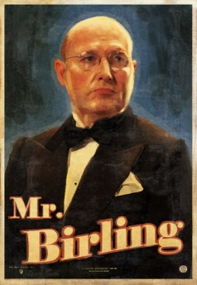

**Mr. Birling**

* Mr. Birling’s actions of sacking Eva from her job for asking for more money aren’t as grave as others; however he did start the whole thing. The major flaw in his personality is that he seems to show no remorse for Eva.  He seems to be a very hard man, and shows no regret for what he’s done.
* He merely stated that, **‘If you don’t come down sharply on some of these people they will soon be asking for the earth’.**
* His greed is what mainly led him to carrying out these life-destroying actions.

**Sheila**

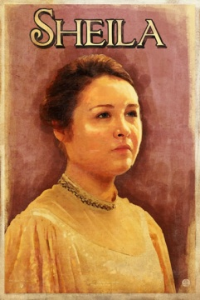

* Sheila was the second person that the Inspector turned on, and her part in the run up to Eva’s death shows her in an unfavourable light as she turned on Eva because she was jealous of her. Sheila wrongfully used her position as an important customer to turn Eva out of a job.  She even admits, **‘it was my own fault’,** and that she **‘was in a furious temper’.**
* Unlike her father, Sheila does show empathy for Eva and regrets her actions.

**Gerald**

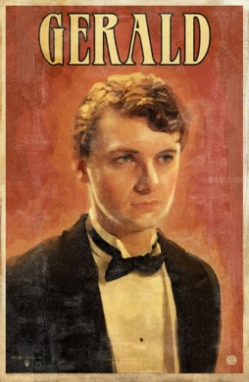

* Gerald was the third person to be accused of leading Eva to suicide. He feels differently towards Eva as he knew her personally, not as Eva Smith but as Daisy Renton; who, for a while, was his mistress, until it was no longer convenient for him.
* It could be argued that Gerald came as almost a “saviour” to Eva as when he first saw her he said that she ‘gave me a glance that was nothing more than a cry for help’. I believe that he did genuinely care for Eva but he didn’t love her as he admitted that: ‘I didn’t feel about her as she felt about me’.
* Gerald improved her circumstance in some ways, although he did use her and then dump her.

**Eric**

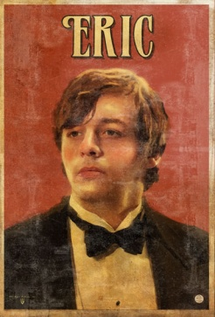

Eric, the young, alcoholic Birling, used Eva “at the end of a stupid drunken evening as if she were a thing, an animal”.

He raped her and got her pregnant, making it even harder for her to survive. She even refused to accept Eric’s stolen money, so she was left homeless and penniless, pregnant and starving; with one option left: to try and get help off Eric’s mother- Mrs. Birling.

**Mrs. Birling**

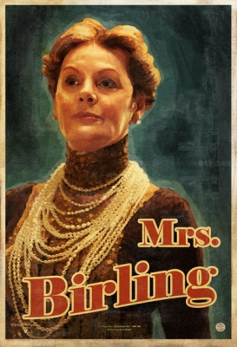

* When Eva is found in such an underprivileged situation, she tries to seek help from Mrs. Birling’s charity organisation.
* Eva is so desperate that she decides to go by the name of “Mrs. Birling”, not realising that she was speaking to Eric’s mother.
* Eva is declined from Mrs. Birling’s charity, and in my opinion, this action is the worst, most selfish action of all as it is the final one that leads her to committing suicide along with Eric’s baby.

**Conclusion**

Eva Smith did not deserve to die this way because all she did to start it was try and fight for higher wages.

Priestly, in many ways, manages to prove his socialist views:

**"We are members of one body. We are responsible for each other“**

He shows that with a narrow-minded, harshly capitalist way of thinking lives can be destroyed.