What do the characters in ‘An Inspector Calls’ represent in society?
Name | What do they represent? | What does J.B Priestley want us to learn?
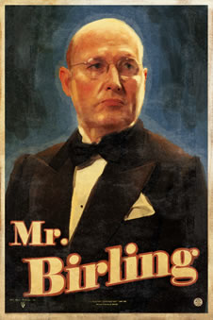 | He represents the greed of the wealthy.  He also represents the arrogance and detachment of the upper class.  He also represents the stubbornness of the upper class, and their unwillingness to change.
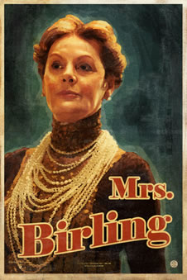 | She represents the ignorance of the upper class.  She also represents the refusal of the upper class to accept blame for their actions.
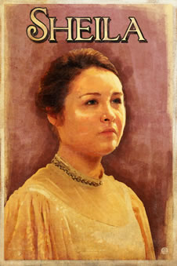 | She represents the younger generation and the changing attitudes of women.  She represents the younger generation’s willingness to accept responsibility.  She represents an honest example of the flaws on human beings. She accepts her imperfects and knows she needs to change.

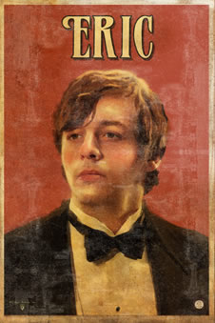 | He represents the younger generation and their willingness to accept blame.  He represents some of the issues that arise from having too much money and too little sense.  He represents the differences and problems that arise between the older and younger generation.
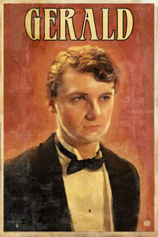 | He represents the younger generation who still aspire to be like the older generation.  He represents those who can be corrupted by money and power.  He represents some good qualities, like how the wealthy could help the poor.  He represents how some people could have more power or control over others because of their wealth.
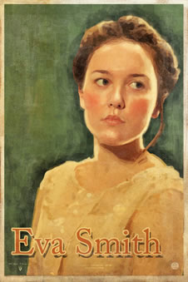 | She represents the poor and how they were mistreated and victims of prejudice.  She represents the courage shown by the poor to try and change their poor living conditions.  She represents how the poor can be controlled and manipulated by the rich.

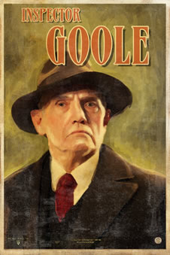The Inspector represents J.B. Priestley’s opinions and views on how life as we knew it needed to change.

When the Inspector criticizes the Birling family for all their different faults, imagine J.B. Priestly criticizing the behaviour of the upper class, and how society benefited the rich, but punished the poor.

Below, read the statements that J.B. Priestly was encouraging his audience to think about.
Try and find a quote from the play that is a good example of how Priestley represents these ideas.

What J.B. Priestly believed | An example of how he has used a character to represent this view
The rich are isolated and believe they are separate, or above, the poor. | Mr Birling says: “…a man has to mind his own business and look after himself and his own.”
The rich are greedy
The older generation are stubborn and will not accept blame
We need to respect individuals
The younger generation are going to promote social change
We need to look after one another
We need to treat women equally
The rich are ignorant and feel overly secure in their position

