Understanding the Social and Historical Context of ‘An Inspector Calls’

Order the information in the text boxes in the correct place along the timeline below. As you read the play, consider how Priestley was influenced by events around him when writing the play. What do you think he was hoping to achieve? What did he want his audience to take away from the production?
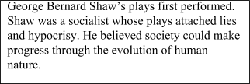
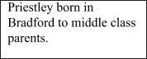

1894

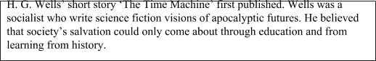
1895

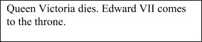
1901

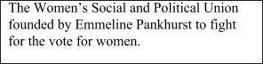
1903

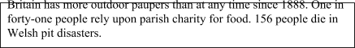
1904/5

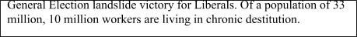
1906

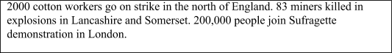
1908

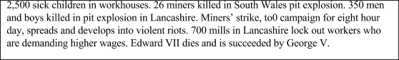
1909/10

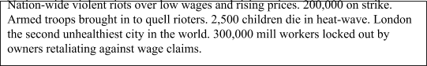
1911
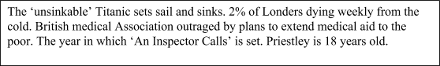

1912

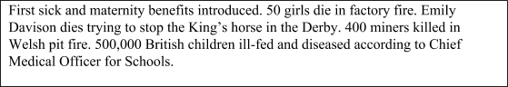

1913

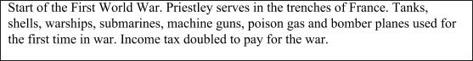
1914

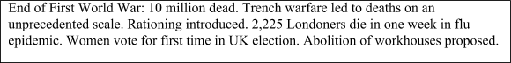
1918

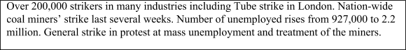
1919

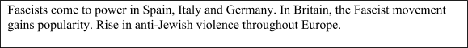
1933

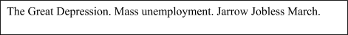
1936

1937

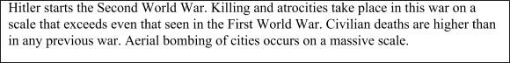
1939

1942

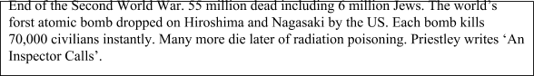
1945

