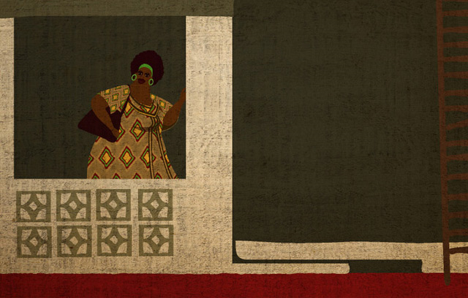
Mma Ramotswe had a detective agency in Africa, at the foot of Kgale Hill. These were its assets: a tiny white van, two desks, two chairs, a telephone, and an old typewriter. Then there was a teapot, in which Mma Ramotswe – the only lady private detective in Botswana – brewed redbush tea. And three mugs – one for herself, one for her secretary, and one for the client. What else does a detective agency really need? Detective agencies rely on human intuition and intelligence, both of which Mma Ramotswe had in abundance. No inventory would ever include those, of course.
But there was also the view, which again could appear on no inventory. How could any such list describe what one saw when one looked out from Mma Ramotswe’s door? To the front, an acacia tree, the thorn tree which dots the wide edges of the Kalahari; the great white thorns, a warning; the olive-grey leaves, by contrast, so delicate. In its branches, in the late afternoon, or in the cool of the early morning, one might see a Go-Away Bird, or hear it, rather. And beyond the acacia, over the dusty road, the roofs of the town under a cover of trees and scrub bush; on the horizon, in a blue shimmer of heat, the hills, like improbable, overgrown termite-mounds.
Everybody called her Mma Ramotswe, although if people had wanted to be formal, they would have addressed her as Mme Mma Ramotswe. This is the right thing for a person of stature, but which she had never used of herself. So it was always Mma Ramotswe, rather than Precious Ramotswe, a name which very few people employed.
She was a good detective, and a good woman. A good woman in a good country, one might say. She loved her country, Botswana, which is a place of peace, and she loved Africa, for all its trials. I am not ashamed to be called an African patriot, said Mma Ramotswe. I love all the people whom God made, but I especially know how to love the people who live in this place. They are my people, my brothers and sisters. It is my duty to help them to solve the mysteries in their lives. That is what I am called to do.
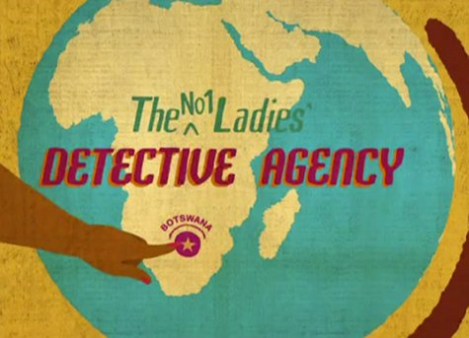
Mma Ramotswe set up the No. 1 Ladies’ Detective Agency with the proceeds of the sale of her father’s cattle. He had owned a big herd, and had no other children; so every single beast, all one hundred and eighty of them, including the white Brahmin bulls whose grandparents he had bred himself, went to her.
‘I want you to have your own business,’ he said to her on his death bed. ‘You’ll get a good price for the cattle now. Sell them and buy a business. A butchery maybe. A bottle store. Whatever you like.’
She held her father’s hand and looked into the eyes of the man she loved beyond all others, her Daddy, her wise Daddy, whose lungs had been filled with dust in those mines and who had scrimped and saved to make life good for her. It was difficult to talk through her tears, but she managed to say: ‘I’m going to set up a detective agency. Down in Gaborone. It will be the best one in Botswana. The No. 1 Agency.’
For a moment her father’s eyes opened wide and it seemed as if he was struggling to speak.
‘But . . . but . . .’
But he died before he could say anything more, and Mma Ramotswe fell on his chest and wept for all the dignity, love and suffering that died with him.
She had a sign painted in bright colours, which was then set up just off the Lobatse Road, on the edge of town, pointing to the small building she had purchased: THE NO. 1 LADIES’ DETECTIVE AGENCY. FOR ALL CONFIDENTIAL MATTERS AND ENQUIRIES. SATISFACTION GUARANTEED FOR ALL PARTIES. UNDER PERSONAL MANAGEMENT.
There was considerable public interest in the setting up of her agency. There was an interview on Radio Botswana, in which she thought she was rather rudely pressed to reveal her qualifications, and a rather more satisfactory article in The Botswana News, which drew attention to the fact that she was the only lady private detective in the country. This article was cut out, copied, and placed prominently on a small board beside the front door of the agency.
After a slow start, she was rather surprised to find that her services were in considerable demand. She was consulted about missing husbands, about the creditworthiness of potential business partners, and about suspected fraud by employees. In almost every case, she was able to come up with at least some information for the client; when she could not, she waived her fee, which meant that virtually nobody who consulted her was dissatisfied. People in Botswana liked to talk, she discovered, and the mere mention of the fact that she was a private detective would let loose a positive outpouring of information on all sorts of subjects. It flattered people, she concluded, to be approached by a private detecttive, and this effectively loosened their tongues.
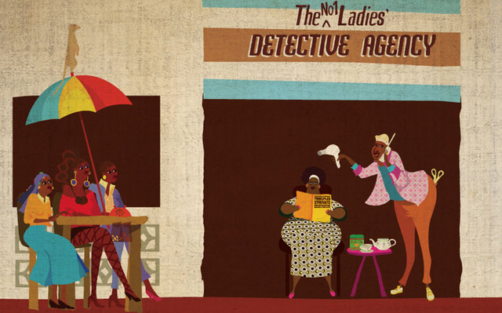
This happened with Happy Bapetsi, one of her earlier clients. Poor Happy! To have lost your daddy and then found him, and then lost him again . . .
‘I used to have a happy life,’ said Happy Bapetsi. ‘A very happy life. Then this thing happened, and I can’t say that any more.’
Mma Ramotswe watched her client as she sipped her bush tea. Everything you wanted to know about a person was written in the face, she believed. It’s not that she believed that the shape of the head was what counted – even if there were many who still clung to that belief; it was more a question of taking care to scrutinise the lines and the general look. And the eyes, of course; they were very important. The eyes allowed you to see right into a person, to penetrate their very essence, and that was why people with something to hide wore sunglasses indoors. They were the ones you had to watch very carefully.
Now this Happy Bapetsi was intelligent; that was immediately apparent. She also had few worries – this was shown by the fact that there were no lines on her face, other than smile lines of course. So it was man trouble, thought Mma Ramotswe. Some man has turned up and spoilt everything, destroying her happiness with his bad behaviour.
‘Let me tell you a little about myself first,’ said Happy Bapetsi. ‘I come from Maun, you see, right up on the Okavango. My mother had a small shop and I lived with her in the house at the back. We had lots of chickens and we were very happy.
‘My mother told me that my Daddy had left a long time ago, when I was still a little baby. He had gone off to work in Bulawayo and he had never come back. Somebody had written to us to say that he thought that my Daddy was dead, but he wasn’t sure. He said that he had gone to see somebody at Mpilo Hospital one day and as he was walking along a corridor he saw them wheeling somebody out on a stretcher and that the dead person on the stretcher looked remarkably like my Daddy. But he couldn’t be certain.
‘So we decided that he was probably dead, but my mother did not mind a great deal because she had never really liked him very much. And of course I couldn’t even remember him, so it did not make much difference to me.
‘I went to school and did very well in my exams and went off to Gaborone to learn how to be a book-keeper. I then got a job in the bank and I was given promotion after promotion. Now I am the No. 1 sub-accountant and I don’t think I can go any further because all the men are worried that I’ll make them look stupid. But I don’t mind. I get very good pay and I have a nice house with four rooms and I am very happy. To have all that by the time you are thirty-eight is good enough, I think.’
Mma Ramotswe smiled. ‘That is all very interesting. You’re right. You’ve done well.’
‘I’m very lucky,’ said Happy Bapetsi. ‘But then this thing happened. My Daddy arrived at the house.’
Mma Ramotswe drew in her breath. She had not expected this; she had thought it would be a boyfriend problem. Fathers were a different matter altogether.
‘He just knocked on the door,’ said Happy Bapetsi. ‘It was a Saturday afternoon and I was taking a rest on my bed when I heard his knocking. I got up, went to the door, and there was this man, about sixty or so, standing there with his hat in his hands. He told me that he was my Daddy, and that he had been living in Bulawayo for a long time but was now back in Botswana and had come to see me.
‘You can understand how shocked I was. I had to sit down, or I think I would have fainted. In the meantime, he spoke. He told me my mother’s name, which was correct, and he said that he was sorry that he hadn’t been in touch before. Then he asked if he could stay in one of the spare rooms, as he had nowhere else to go.
‘I said that of course he could. In a way I was very excited to see my Daddy and I thought that it would be good to be able to make up for all those lost years and to have him staying with me, particularly since my poor mother died. So I made a bed for him in one of the rooms and cooked him a large meal of steak and potatoes, which he ate very quickly. Then he asked for more.
‘That was about three months ago. Since then, he has been living in that room and I have been doing all the work for him. I make his breakfast, cook him some lunch, which I leave in the kitchen, and then make his supper at night. I buy him one bottle of beer a day and have also bought him some new clothes and a pair of good shoes. All he does is sit in his chair outside the front door and tell me what to do for him next.’
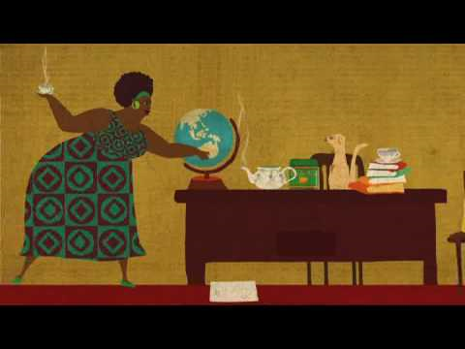
‘Many men are like that,’ interrupted Mma Ramotswe.
Happy Bapetsi nodded. ‘This one is specially like that. He has not washed a single cooking pot since he arrived and I have been getting very tired running after him. He also spends a lot of my money on vitamin pills and cured beef.
‘I would not resent this, you know, except for one thing. I do not think that he is my real Daddy. I have no way of proving this, but I think that this man is an impostor and that he heard about our family from my real Daddy before he died and is now just pretending. I think he is a man who has been looking for a retirement home and who is very pleased because he has found a good one.’
Mma Ramotswe found herself staring in frank wonderment at Happy Bapetsi. There was no doubt but that she was telling the truth; what astonished her was the effrontery, the sheer, naked effrontery of men. How dare this person come and impose on this helpful, happy person! What a piece of chicanery, of fraud! What a piece of outright theft in fact!
‘Can you help me?’ asked Happy Bapetsi. ‘Can you find out whether this man is really my Daddy? If he is, then I will be a dutiful daughter and put up with him. If he is not, then I should prefer for him to go somewhere else.’
Mma Ramotswe did not hesitate. ‘I’ll find out,’ she said. ‘It may take me a day or two, but I’ll find out!’
Of course it was easier said than done. There were blood tests these days, but she doubted very much whether this person would agree to that. No, she would have to try something more subtle, something that would show beyond any argument whether he was the Daddy or not.
Mma Ramotswe picked up the nurse’s uniform from her friend Sister Gogwe. It was a bit tight, especially round the arms, as Sister Gogwe, although generously proportioned, was slightly more slender than Mma Ramotswe. But once she was in it, and had pinned the nurse’s watch to her front, she was a perfect picture of a staff sister at the Princess Marina Hospital. It was a good disguise, she thought, and she made a mental note to use it at some time in the future.
As she drove to Happy Bapetsi’s house in her tiny white van, she reflected on how the African tradition of support for relatives could cripple people. If you believed in the old Setswana morality, you couldn’t turn a relative away, and there was a lot to be said for that. But it did mean that charlatans and parasites had a very much easier time of it than they did elsewhere. They were the people who ruined the system, she thought. They’re the ones who are giving the old ways a bad name.
As she neared the house, she increased her speed. This was an errand of mercy, after all, and if the Daddy were sitting in his chair outside the front door he would have to see her arrive in a cloud of dust. The Daddy was there, of course, enjoying the morning sun, and he sat up straight in his chair as he saw the tiny white van sweep up to the gate. Mma Ramotswe turned off the engine and ran out of the car up to the house.
‘Dumela Rra,’ she greeted him rapidly. ‘Are you Happy Bapetsi’s Daddy?’
The Daddy rose to his feet. ‘Yes,’ he said proudly. ‘I am the Daddy.’
Mma Ramotswe panted, as if trying to get her breath back. ‘I’m sorry to say that there has been an accident. Happy was run over and is very sick at the hospital. Even now they are performing a big operation on her.’
The Daddy let out a wail. ‘Aiee! My daughter! My little baby Happy!’
A good actor, thought Mma Ramotswe, unless . . . No, she preferred to trust Happy Bapetsi’s instinct. A girl should know her own Daddy even if she had not seen him since she was a baby.
‘Yes,’ she went on. ‘It is very sad. She is very sick, very sick. And they need lots of blood to make up for all the blood she’s lost.’
The Daddy frowned. ‘They must give her that blood. Lots of blood. I can pay.’
‘It’s not the money,’ said Mma Ramotswe. ‘Blood is free. We don’t have the right sort. We will have to get some from her family, and you are the only one she has. We must ask you for some blood.’
The Daddy sat down heavily.
‘I am an old man,’ he said.
Mma Ramotswe sensed that it would work. Yes, this man was an impostor.
‘That is why we are asking you,’ she said. ‘Because she needs so much blood, they will have to take about half your blood. And that is very dangerous for you. In fact, you might die.’
The Daddy’s mouth fell open.
‘Die?’
‘Yes,’ said Mma Ramotswe. ‘But then you are her father and we know that you would do this thing for your daughter. Now could you come quickly, or it will be too late. Doctor Moghile is waiting.’
The Daddy opened his mouth, and then closed it.

