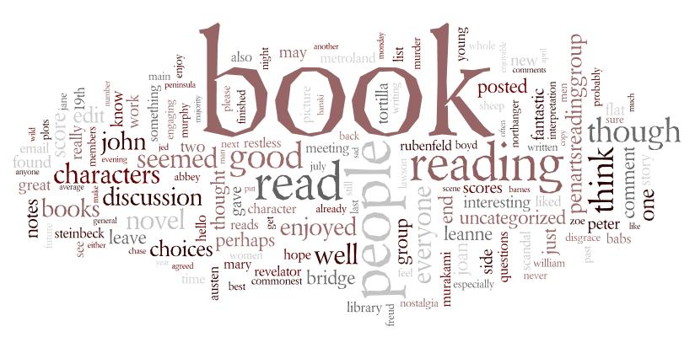Narrative Writing Pack

Name:_______________________________

Class:_________________________________

“It's like everyone tells a story about themselves inside their own head. Always. All the time. That story makes you what you are. We build ourselves out of that story.”
― Patrick Rothfuss

“After nourishment, shelter and companionship, stories are the thing we need most in the world.”
― Philip Pullman

“Most of the basic material a writer works with is acquired before the age of fifteen.”
― Willa Cather

“Artists use lies to tell the truth. Yes, I created a lie. But because you believed it, you found something true about yourself.”
― Alan Moore
What Makes an Interesting Story?
Take another look at the quotations on the front page of the booklet. What do they tell us about telling tales? Why do you think stories are important? Discuss these questions with a partner and be ready to feedback your ideas to the class.

Task One: What are the different elements needed to create an interesting short story? Complete the mind map below with your ideas:

What makes an interesting
short story?

Task Two: Now read the three short stories on the following pages. Use a marker pen to highlight features that you think make an effective short story. If you find something you haven’t yet considered, add it to your mind map. After each story think, pair and share with your partner.
Moving On
I can see her from my window. In her bedroom titivating herself and getting ready to go out. She was my best friend. But not any more.
I can't help but think back to how different things used to be between us, just a few years ago. I remember the first day I met her, when she burst in to my world like a ray of sunshine exclaiming "We will be best friends forever!" A promise she failed to keep.
At first we did everything together - went shopping, ate in restaurants, went for drives in the car, and every year she insisted I went on holiday with her and her family. Always to a beach. I never told her but I hated the way the sand never seemed to wash out of my hair.
She introduced me to my first ever boyfriend. He was called Ken and was the love of my life. He was so handsome and well dressed and she always said we belonged together. That was until... That year we went to Menorca - another beach holiday - but the first time Ken and I had been away as a couple. We all had a great time! But two days before we came home, I stayed at the hotel while the rest of them went on a boat trip. They were gone for ages, but I enjoyed the peace and quiet. When she came back I could tell she had been crying. She hugged me close and sobbed. There had been an accident on the boat and my Ken was lost forever - presumed drowned.
When we got back home things were never the same again. I was just numb, but she cried a river. She sobbed when she saw his car in the driveway, when she opened the wardrobe and saw his clothes, and when she stepped on his surfboard - his pride and joy - and broke it. I just smiled at her and hoped in my eyes she could see I forgave her. She tried at the start to make everything better, taking me out, buying me new clothes and even introducing me to a new man.
I don't know exactly when we started to drift apart. Her visits dwindled and I saw her less and less. She has a new friend now, called Sarah, who is beginning to take my place. I met Sarah once briefly, and she laughed at me. I looked at my best friend and could see how embarrassed she was with me. I knew then our time was over.
She is still fixing her hair, music blaring through the open window. Suddenly her bedroom door opens. "Turn that music down Lucy!" her mum yells, "Have you decided what things you are giving to the charity shop yet? I'm going now!" She looked over - directly at me. "Yeah mum, I think the dolls house and Barbie can go." And my world went black as the plastic bag was placed over my home.

Find Me
The boy caressed the rusty key in his palm. Hours had passed, scouring this unknown territory: a waste of time until he found this reward, this trophy. With the eagerness of an archaeologist he rubbed away at the encrusted dirt until his grimy fingers revealed two words, inscribed on the key's shaft - "Find Me".
The instant he stepped foot into the house again, all his senses marvelled at the uniqueness of the Manor. The sinewy fingers of stale pipe tobacco smoke crawled up into his nostrils, and the irritating sound of creaking chafed at his eardrums as he pounded the wooden floorboards searching for hidden curiosities.
His mother had sunk into poverty since her husband had died in The Great War. A hardworking and trustworthy woman, she was fortunate to have been given the position of housekeeper by the owners of Pensfort Manor whilst they were travelling. Her son, an exuberant nine year old, short for his age but fearless nonetheless, was delirious to find himself free to roam the many formal gardens, orchards and wildernesses surrounding the Manor and play to his heart's content within the walls of the ambling house.
Nimbly traversing the many corridors, the boy wandered into a room, yet undiscovered, and pondered over its impressive paintings with elaborate gilt frames which looked to him centuries old. Someone tapped him on the back - it was a delicate touch, more that of a child than an adult, but surely not his mother's. There it was again, a gentle prod, undoubtedly real, for he felt fingernails pierce his shirt.
He wove around to face a life sized portrait of a girl - she had flowing golden locks, peaceful blue eyes but a sad pale face full of longing and loneliness. In the background of the painting was a decaying oak door with a rusting lock...
The girl moved! He could swear on it. She seemed to be clawing at his hand - why? He spread out his palm: of course, the key! She smiled but her eyes were bulging with hunger as she beckoned him hypnotically to come forward. The girl pointed eagerly to the lock in the door behind her; as he slid the key into it, a huge wave of light flooded out of the painting, engulfing him and his screams for help.
"Son?" his mother called to him. No response. "Son?" All day she had searched every inch of the house in vain desperation before she remembered the deserted corridor of rooms the owners of the house had told her not to disturb. Her heart pounded as she retraced the boy's boot prints on the dusty floorboards. On entering the room, her eyes followed the footprints leading curiously up to the gloomy picture of the girl; she recoiled in horror as her eyes took in the scene before her: the girl's pale hand rested on the shoulder of a new companion, one that was not meant to be there...her son.
Umbrella
It was a cloudy night; the darkness covered the city like a thick blanket. The wind blew gusts of air smelling of car fumes through the streets; it sneaked under the cracks of doors and whispered down sooty chimneys.
Mr Bell hurried down a dark street, holding onto his bowler hat so that the harsh breeze couldn't steal it. The wind blew harder, almost blowing the short, stout man off-course. Eyes narrowed, Mr Bell tried again to walk into the path of the determined gale. A hazy drizzle of misty rain drifted down in sheets, making him shiver and cough. Cursing the cold, he drew his coat tighter around his large figure. As he made to clamp his hat to his head again, he spotted something black and flapping on the pavement. An umbrella!
His heart leapt; the umbrella would be perfect! Feeling pleased with himself, Mr Bell ran towards it and snatched it up. The handle was smooth and glossy, and the waterproof dome was black and very large.
As Mr Bell raised it above his head, something remarkable happened. He began to feel lighter as he ran over the cobbled street, holding tight. Lighter and lighter. With a gasp, he realised that his leather shoes were no longer making contact with the pavement. He was flying! The wind lifted him up like hundreds of hands, all pushing upwards.
With a delighted and shocked shout, Mr Bell gazed down at the sprawling city below him. The street lamps looked like beautiful, luminous flowers reaching up to him. Cars reminded him of jewel-coloured beetles crawling through the concrete maze.
The wind led him towards the park; it was the only splash of green in a grey ocean of buildings and roads. Clutching the umbrella tightly, he drifted towards two bronze statues of lions guarding the park entrance. Mr Bell outstretched his free hand and reached towards one. As he passed, he patted it on its cold head. The lion roared deeply and shook its impressive mane, whilst watching the small man float past. Wide-eyed, Mr Bell swung himself away. The umbrella swayed dangerously and as he grasped the handle harder, he waited dizzily for the world to stop spinning.
Still the wind carried him on. He glanced back at the now still statues. The trees swayed in time with the umbrella as he drifted higher again. A white barn owl flew past Mr Bell like a winged ghost.
As he rose, he scanned the sprawling city for his house. There. He gently coaxed the umbrella down towards his street. The wind rushed down and with a bump, Mr Bell landed outside his house. He looked around to check that nobody had noticed him disembarking, before making his way up the garden path. The promise of light and warmth beckoned him inside. As he stood on the front porch, he folded the umbrella up and smiled as he thought about what an exciting bedtime story his daughters would have that night.

GCSE Narrative Writing Mark Scheme
Content & Organisation (14 marks)

Band One (1-4 marks) Band Two (5-7 marks) Band Three (8-10 marks) Band Four (11-14 marks)

- Controlled & coherent writing
- Narrative is organised and structured purposefully
- Range of vocabulary, occasionally used for effect
- The writing shows originality and imagination
- Material is prioritised to maintain interest
- Cohesion is reinforced by text connectives
- Ambitious vocabulary
- Basic sense of plot
- Simple chronological writing
- Limited range of vocabulary
- Basic sense of characterisation
- Appropriate beginning & conclusion
- There is a range of vocabulary

Grammar – sentences, spelling and punctuation (6 marks)

Band One (1-2 marks) Band Two (3 marks) Band Three (4 marks) Band Four (5-6 marks)
- Sophisticated used of sentences types and lengths for particular effects
- Accurate punctuation to clarify meaning
- Virtually all spellings, including complex irregular words, are correct
- Sentences are simple & compound
- Punctuation is attempted with some accuracy
- Simple words are spelt accurately
- Sentences are varied and complex sentences are used
- Some control of a range of punctuation
- Control of tense and agreement is generally secure
- Varied sentence length and range for effect
- Most spellings, including irregular words, are correct
- Control of tense and agreement is secure

Story Openings

Below are the very first sentences from various children’s novels. Look at each example of an opening sentence and discuss whether or not it would interest you as a reader. Then think about what the author has done to ‘hook’ you into his/her book.
Not for the first time, an argument had broken out over breakfast at number four, Privet Drive.
‘Yes,’ said Tom bluntly, on opening the front door. ‘What d’you want?’

It was a dark, blustery afternoon in spring, and the city of London was chasing a small mining town across the dried-out bed of the North Sea.
Once, there were four children whose names were Peter, Susan, Edmund and Lucy.

It was 7 minutes after midnight.
Once I was living in an orphanage in the mountains and I almost caused a riot.

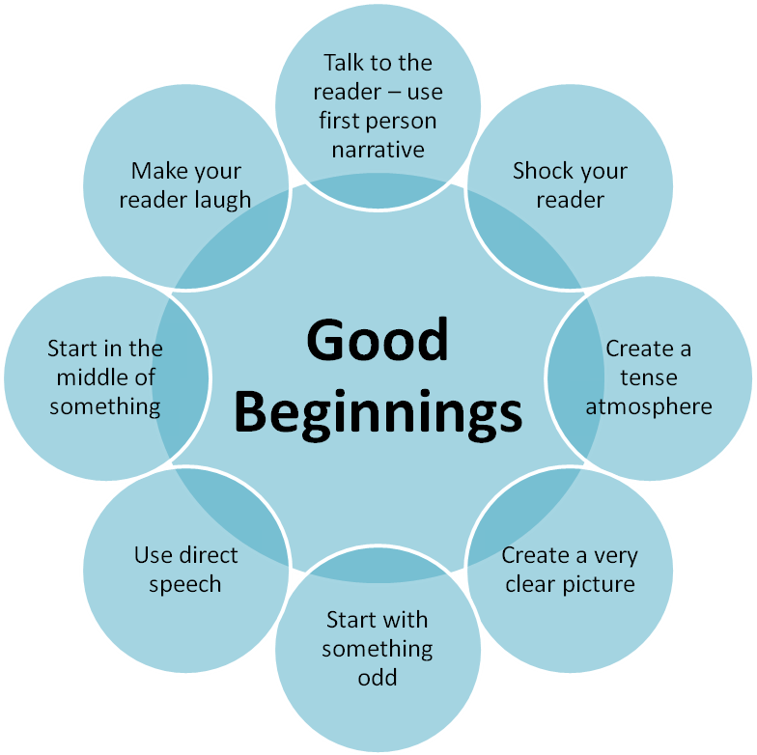
Choose an appropriate hook from the ‘good beginnings’ wheel and write the opening of a story below:
_________________________________________________________________________________________________________________________________________________________________________________________________________________

Sentence Openings

One of the most common ways to start a sentence is to begin with the thing being described as subject(first word). So we start with ‘the...’, or ‘she/he/it...’, followed by the verb (action).

For example: The lanky, unkempt fellow slinked down the canal path...

This can become boring. Instead try the following to vary your sentence openings:
- Use an ‘-ly’ (adverb) opening word:Unsteadily, the lanky, unkempt fellow slinked down the alleyway...

- Open using a word ending in ‘-ed’:Terrified, the girl darted out of the path of her pursuer...

- Start the sentence using a word ending in ‘-ing’: Ambling along the canal tow path, the intoxicated thief spied his victim...
Sentence Lengths
Read the following extract:
The attic door creaked open. Something rustled in the darkness. I stared,but could see nothing beyond the vague shapes of old suitcases and trunks piled high. It smelt damp. I struggled up into the attic and wedged the door open.Light poured into darkness. The darkness in the head of the house. I balanced carefully upon the floor beams. I knew that if I stepped onto plaster I could fall straight through into the room below. A cobweb brushed my face and I felt the sudden tickle of a spider crawl across my cheek. As I made my way forwards, it grew darker and colder. I was blocking the light from the attic door. There were piles of old newspapers, brown bags tied with string cardboard boxes and ancient, moth eaten rugs that smelt of mothballs. Thick dust powdered every surface. I kept thinking that I could slip and put my foot through the floor. I stopped at a pile of old camping equipment. It was a jumble of guy ropes, torn canvas, poles, wooden pegs, metal skewers and a mallet. It was there that I saw the hand. It was quite still and white, like a marble.But then it moved.

- What do you notice about the sentence lengths? Why are they important?

- What atmosphere is created in the passage? How does the writer build tension?

- What other techniques does the writer use to create the atmosphere?

Practice Titles
Now it’s time to use the skills you have learnt so far. Choose a title from one of the five below:
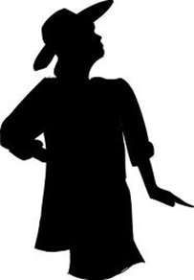
- The Hidden Book

- The Accident
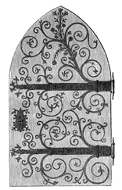
- The Broken Mirror

- The Secret Door

- The Unexpected Guest

Elements to consider when planning your story:

- First person or third person narrative?
- Choose one or two main characters
- Choose one setting
- Consider how much time can take place in the story?
- Consider the time sequence? Does your story take place in chronological order?
- Your story MUST be closely related to your title
- Your story MUST be original and interesting

Task: Plan your story below in a mind map. Resolve the ideas above in your plan.

How low can you go?
Did you know that punctuation has levels?

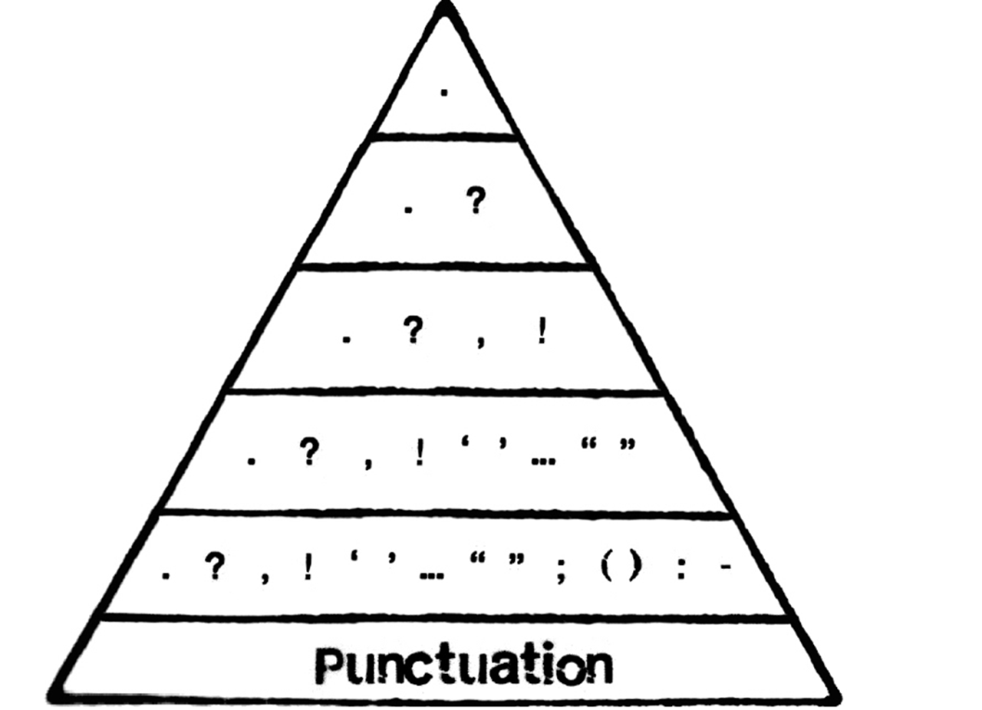

Characterisation

One way of making your writing more interesting is to SHOW rather than TELL.
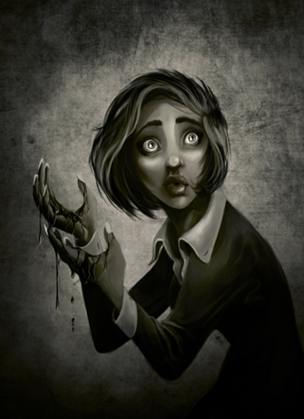For example:
Telling:
She was frightened.
Showing:
Goosebumps travelled up her fair skin and her mouth went horribly dry. Her hands began to shake uncontrollably but her feet became lead weights that refused to move.

Remember to use:
- Interesting verbs - 'doing' words or 'being' words. E.g. 'walk', ‘feel’
- Adverbs – words that add information to the verb.
- Adjectives - describing words that tell you more about nouns.

Task
Create a character using the ‘show, don’t tell’ rule. He or she should express an emotion.
_____________________________________________________________________________________________________________________________________________________________________________________________________________________________________________________________________________________________________________________________________________________________________________________________________________________________________________________________________________________________________________________________________________________________________________________________________________________________________________________________________________________________________________________________________________________________________________________________________________________________________________________________________________
Varied Vocabulary – Synonyms

Task One: Using a thesaurus, create a vocabulary list for the following words. The first one has been done for you.

- Slim: thin, trim, slender, lean, wiry.

- Cold:

- Hot:

- Happy:

- Sad:

Task Two: Use the new words from your vocabulary list in a sentence. The first one has been done for you.

- Slim: The teenage girl was very slender.

- Cold:

- Hot:

- Happy:

- Sad:

Task Three: Make these sentences more interesting by using similes, metaphors, personification, adjectives and adverbs. The first one has been done for you.

- I was very sad.

Tears of sorrow streaked my face.

- He was proud.

- The wind was strong.

- I was excited.

- It was a hot evening.

GCSE Titles
Choose one of the following titles to create your GCSE story:
- The Cheat
- The Coming Storm
- The Betrayal
- Coming Home
- The Gift

- Write about a time when you lost something of importance
- Write about a time when you were forced into doing something that you really didn’t want to do
- Write about a time when something you had carefully planned did not work out as expected
Plan
Use the mind map below to come up with as many ideas as possible based around your title:
Writing Descriptively: Planning Sheet
Five Senses

Sight | Smell | Sound | Taste | Touch
Interesting Vocabulary and Difficult Spellings
Imagery (similes/metaphors/personification)

Descriptive Words (adjectives/adverbs)
Structure of a Short Story
First Sentence: direct speech, exclamation, question …

Beginning (Exposition):
What do you need to tell your reader about the characters, setting and plot to keep them engaged?

Middle (Problem):
What do you need to add to keep your reader interested? How can you build suspense/tension?

Climax:
What is the event that occurs before the problem is solved and the readers’ questions are answered?

Ending (Resolution):
How will you end so that the problem is resolved and satisfy the reader? Will you create an unexpected ending?

You can visualise the story structure as a graph:
Resolution
Climax
Problem

Exposition
Complete a draft of your story below.

Title:

__________________________________________________________________________________________________________________________________________________________________________________________________________________________________________________________________________________________________________________________________________________________________________________________________________________________________________________________________________________________________________________________________________________________________________________________________________________________________________________________________________________________________________________________________________________________________________________________________
____________________________________________________________________________________________________________________________________________________________________________________________________________________________________________________________________________________________________________________________________________________________________________________________________________________________________
____________________________________________________________________________________________________________________________________________________________________________________________________________________________________________________________________________________________________________________________________________________________________________________________________________________________________
____________________________________________________________________________________________________________________________________________________________________________________________________________________________________________________________________________________________________________________________________________________________________________________________________________________________________
____________________________________________________________________________________________________________________________________________________________________________________________________________________________________________________________________________________________________________________________________________________________________________________________________________________________________
____________________________________________________________________________________________________________________________________________________________________________________________________________________________________________________________________________________________________________________________________________________________________________________________________________________________________
____________________________________________________________________________________________________________________________________________________________________________________________________________________________________________________________________________________________________________________________________________________________________________________________________________________________________
____________________________________________________________________________________________________________________________________________________________________________________________________________________________________________________________________________________________________________________________________________________________________________________________________________________________________
____________________________________________________________________________________________________________________________________________________________________________________________________________________________________________________________________________________________________________________________________________________________________________________________________________________________________
____________________________________________________________________________________________________________________________________________________________________________________________________________________________________________________________________________________________________________________________________________________________________________________________________________________________________
__________________________________________________________________________________________________________________________________________________________________________________________________________________________________________________________________________________________________________________________________________________________________________________________________________________________________________________________________________________________________________________________________________________________________________________________________________________________________________________________________________________________________________________________________________________________________________________________________

