Researching Famous British Writers
- For as many of the famous writers below as you are able:
- On the correct part of the timeline add the full names and dates of birth and death of each writer
- Copy and paste a small picture of each writer into the textbox
- Add a list of up to 3 of the writer’s most famous works next to the above
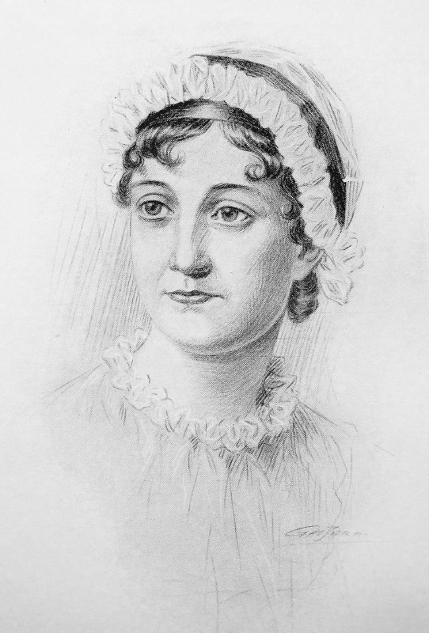
Example: Jane Austen (1775-1817)
Pride and Prejudice, Emma, Mansfield Park

- Select one of the pre 20th century authors from your timeline and create a presentation about his/her life and writing. Use Power Point if possible or make notes, produce cue cards and print out pictures. Do not copy and paste from the Internet. Research the writer using several websites and write up using your own words.

- Give your presentation to the class on your writer. You will need to be able to expand on your bullet points and notes for an interesting presentation.

List of Famous Writers

Geoffrey Chaucer
William Shakespeare
Daniel Defoe
Jane Austen
George Eliot
Charles Dickens
Emily Bronte
Lewis Carroll
Robert Louis Stevenson
Arthur Conan Doyle
Thomas Hardy
D H Lawrence
J R R Tolkien
C S Lewis
Agatha Christie
H G Wells
George Orwell
Roald Dahl
Jacqueline Wilson
J K Rowling

