Slim
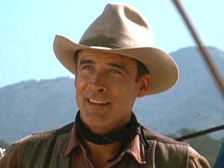Slim is a mysterious man who's authority is built upon the respect and admiration of all those who he works with on the ranch.
Slim’s role on the ranch

Slim is described as the "prince of the ranch" "he moved with a majesty only achieved by royalty and master craftsman" all indicating his authority among those in the ranch.

Throughout the novella, he is always present in situations, in which he acts as a liaison between the problem and solution, to brings justice to them.

As what he says usually goes, it needn't matter if one side dislikes the conclusion, because it was Slim who decided it, it is final.
WHO IS SLIM?

Although we know who Slim is on the outside, we are given no information on his past.

We are told he moved with majesty that can on be "achieved by royalty", which raises the question "why would such a man work on a ranch?"

Steinbeck seems to have left this developed character's development for out imaginations; does he represent the voice of wisdom and authority? God?

Justification for killing?

At the final scene, after George had killed Lennie, it closes with Slim telling George "You hadda do it, George. You had-da". As we know, Slim's purpose in Steinbeck's novella is to put a conclusion to any quarrel, argument, or problem that arises; so when he tells George he "hadda" it's almost justifying it by saying there were no other options, even though a few could have been found. This could either show that Slim would use his authority to lie for the sake of helping others, or that there really wasn't any other way around it.

Slim and The Ranch.

Slim is admired and respected by everyone on the ranch. This is shown by the trust shown in him by those working in the ranch

This, however, makes him unrealistic in a sense that he is seen as perfection whereas others on the ranch all seem to be linked by dead dreams and faults, when Slim has nothing but positive remarks made about him by everyone who mentions his name.

