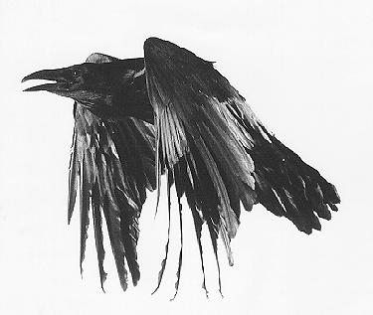The Raven

Once upon a midnight dreary, while I pondered weak and weary,
Over many a quaint and curious volume of forgotten lore,
While I nodded, nearly napping, suddenly there came a tapping,
As of someone gently rapping, rapping at my chamber door.
`'Tis some visitor,' I muttered, `tapping at my chamber door -
Only this, and nothing more.'
And the silken sad uncertain rustling of each purple curtain
Thrilled me - filled me with fantastic terrors never felt before;
So that now, to still the beating of my heart, I stood repeating
`'Tis some visitor entreating entrance at my chamber door -
Some late visitor entreating entrance at my chamber door; -
This it is, and nothing more,'
Presently my soul grew stronger; hesitating then no longer,
`Sir,' said I, `or Madam, truly your forgiveness I implore;
But the fact is I was napping, and so gently you came rapping,
And so faintly you came tapping, tapping at my chamber door,
That I scarce was sure I heard you' - here I opened wide the door; -
Darkness there, and nothing more.
Deep into that darkness peering, long I stood there wondering, fearing,
Doubting, dreaming dreams no mortal ever dared to dream before;
But the silence was unbroken, and the darkness gave no token,
And the only word there spoken was the whispered word, `Lenore!'
This I whispered, and an echo murmured back the word, `Lenore!'
Merely this and nothing more.

