The Telegraph July 2014

Trophy hunting can be a lifeline for Africa's wildlife

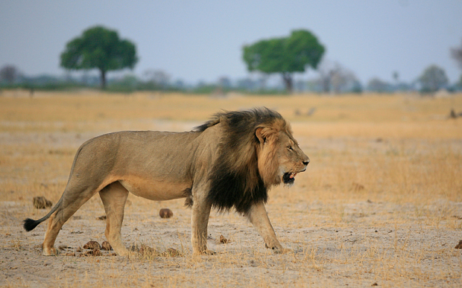
The death of Cecil the Zimbabwean lion has caused outrage. But the truth about hunting big game is that it creates incentives for conservation

There’s something rather tragic about a dead big cat; an apex predator reduced to something akin to a battered teddy crossed with a shagpile carpet. So it’s easy to understand the anger over Cecil, the Zimbabwean lion killed by Walter Palmer, a dentist from Minnesota. Piers Morgan’s tweet, announcing “I’d love to go hunting for killer dentist Dr Walter Palmer, so I can stuff him on my office wall”, is typical of the digital castigation now being heaped on the American.
I wonder, then, what his critics would make of Kirkpatrick, whose head and skin lie by my desk as I type. He’s an Indian leopard, seven foot from head to tail, his face twisted into a sardonic snarl, who took 34 human lives before he met his demise in 1934 with a bullet from the local district commissioner. Would they condemn his killing or that of the leopard of Rudraprayag, shot by Jim Corbett in 1926 after it had eaten 125 souls?
The circumstances and motives differ of course but highlight the complexity that surrounds hunting, both abroad and here in Britain.
Western armchair animal lovers may rail against the ethics of trophy hunting in Africa but it brings considerable income to poor countries. A 2006 scientific paper estimated that “trophy hunting generates gross revenues of at least $201 million per year in sub-Saharan Africa: from a minimum of 18,500 clients”. It also found that “a minimum of 1,394,000 km2 is used for trophy hunting” and concluded that it creates “economic incentives for conservation over vast areas”.
Legalised, controlled hunting can be a lifeline for some of Africa’s most endangered species – and South Africa is leading the way. While most of Africa’s black rhino population is under assault from poaching, with a decline from some 500,000 animals at the turn of the 20th century to just over 5,000 today, the white rhino population has grown from 50 in the 1900s to over 20,000 today. And most of those are in South Africa, where you can legally hunt them.
Many hunters think other African countries should follow South Africa’s example and encourage well-organised, controlled culling of species, so giving them a value to those that live with them. They argue that a rhino, like anything else, will eventually die of old age, so why not allow an elderly beast to be shot and charge fees that can be used to fund effective anti-poaching measures?
That argument fails to convince those who find any form of hunting repugnant, who condemn anyone who hunts as “barbaric”, a term routinely used against those who follow fieldsports here. But being an “animal lover” does not automatically make you a good conservationist.
Those celebrating the SNP’s scuppering of the Conservatives’ attempt to bring foxhunting legislation into line with Scotland should ponder why foxes are not made a protected species in this country. It’s simply because such a measure would carry no credence with real conservationists. Even the RSPB controls foxes, along with other opportunistic predators.
The RSPB accepts, albeit reluctantly, that populist conservation thinking, while cuddly, does not work in a small country where there’s no such thing as a “natural environment”. In the UK we spend £480 million annually on agri-environment schemes yet in the past 50 years alone, 60 per cent of 3,148 species studied in Britain have declined, one third of them seriously. Unpalatable as it may be to sentimentalists, the only places where you will find thriving populations of lapwings and other ground-nesting birds, such as curlews and grey partridges, are on estates with diligent gamekeepers who control our flourishing hordes of carrion crows, magpies, rats and foxes.
As someone whose primary motivation for hunting is to put something delicious on the table – and I do love a warm woodpigeon salad – I don’t quite understand Walter Palmer’s desire to shoot a lion with a bow and arrow. But when I’m at the Game Fair this weekend, along with the thousands of others who use their own money to improve our rivers, moors and woodlands, I know I’m with the people that really make the world a better place.

By Jonathan Young

