**World War One**

**Poetry Booklet**

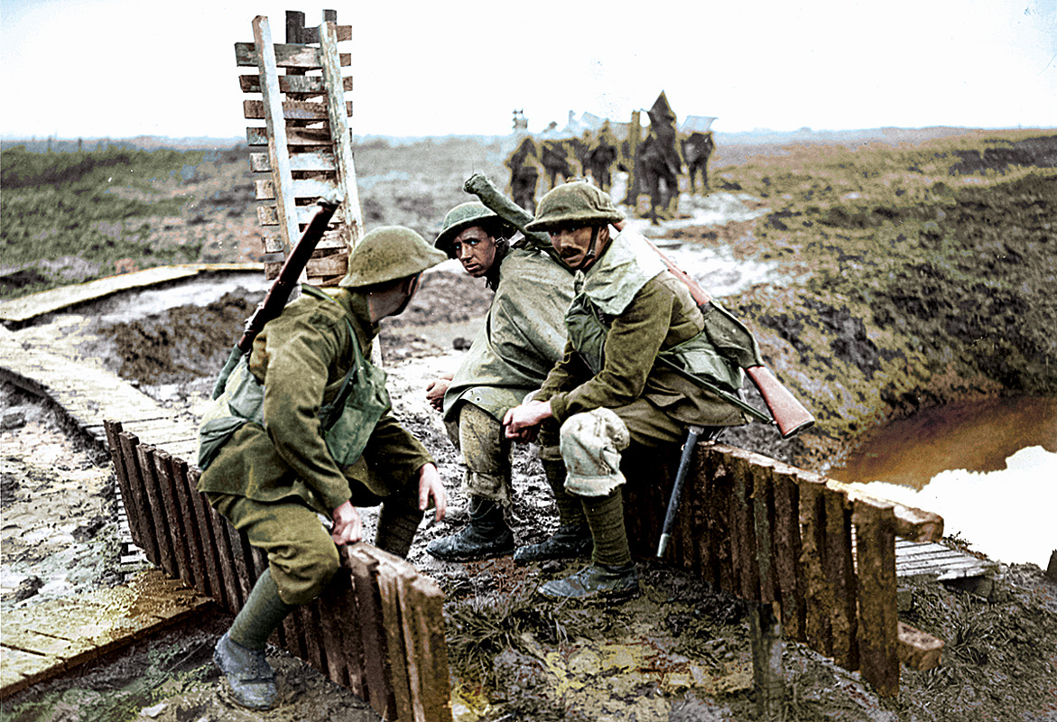

**YR 9**

**Introduction**

War has always inspired poetry. It has been around for as long as there have been wars, one of the oldest examples being ‘The Illiad’ by an ancient Greek poet called Homer. This poem depicted the Trojan wars (and the famous *Trojan Horse*) and was composed around 75 BC, roughly two thousand years ago. War poetry brings history to life by telling us the private thoughts of men and women who have experienced conflict between nations.

Some of the most famous poems and plays written in the English language about war were “*Henry V* ” by Shakespeare, about the battle of Agincourt in 1415 and, “The Charge of the Light Brigade” by Alfred Tennyson about the Crimean War in the 1850s. These are all stories of heroism and glory and depict the bravery of the soldiers.

However, World War One saw a complete change in the way wars were fought and the attitudes towards them. More advanced technology saw death on a huge scale and there were nearly a million British casualties. In total over 8.5 million men were killed during the ‘Great War’. This in turn created a new breed of poets such as Wilfred Owen and Siegfried Sassoon, who wrote in protest of the war and its dire conditions. This study pack concentrates on the poetry written during the First World War for this reason.

At the beginning of the war in August 1914, people had no idea of the scale and length of the conflict they were to be involved in and people were eager to enlist in a war that they though would be over by Christmas.

Look at the poem on the next page by Jessie Pope, who wrote for the Daily Mail newspaper.

1. How would this poem make you feel as a young person whose country was at war?
2. Are there any phrases from this poem that would make you feel a certain way? Why?
3. What do you think the poet feels about war?
4. Why do you think the poet wrote this poem?
5. What is the effect of the repetition in the poem?
6. This poem made many soldiers angry after they had been to the front, in particular Wilfred Owen. Why do you think this might be?



**“The Call”**

By *Jessie Pope (1914)*

W

ho's for the trench—

Are you, my laddie?

Who'll follow French—

Will you, my laddie?

Who's fretting to begin,

Who's going out to win?

And who wants to save his skin—

Do you, my laddie?

Who's for the khaki suit—

Are you, my laddie?

Who longs to charge and shoot—

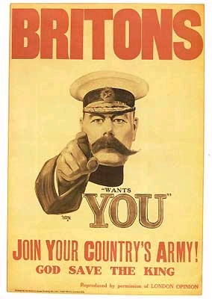

Do you, my laddie?

Who's keen on getting fit,

Who means to show his grit,

And who'd rather wait a bit—

Would you, my laddie?

Who'll earn the Empire's thanks—

Will you, my laddie?

Who'll swell the victor's ranks—

Will you, my laddie?

When that procession comes,

Banners and rolling drums—

Who'll stand and bite his thumbs—

Will you, my laddie?

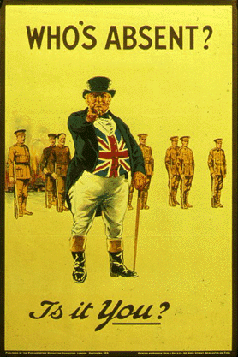

# Poetic Techniques

|  |  |  |  |  |  |  |  |  |  |  |  |  |  |  |
| --- | --- | --- | --- | --- | --- | --- | --- | --- | --- | --- | --- | --- | --- | --- |
| **N** | **G** | **E** | **G** | **N** | **M** | **E** | **Y** | **B** | **W** | **U** | **T** | **V** | **H** | **Q** |
| **G** | **O** | **S** | **P** | **O** | **A** | **E** | **N** | **R** | **W** | **C** | **S** | **F** | **G** | **F** |
| **Y** | **Z** | **I** | **Q** | **I** | **B** | **N** | **T** | **F** | **F** | **U** | **G** | **O** | **U** | **N** |
| **C** | **F** | **P** | **T** | **T** | **A** | **B** | **F** | **A** | **J** | **R** | **I** | **Z** | **P** | **A** |
| **Q** | **S** | **F** | **Z** | **A** | **J** | **E** | **Z** | **X** | **P** | **Y** | **C** | **P** | **I** | **H** |
| **A** | **Q** | **U** | **H** | **R** | **C** | **F** | **S** | **X** | **G** | **H** | **R** | **E** | **T** | **F** |
| **Q** | **X** | **S** | **D** | **E** | **I** | **I** | **R** | **O** | **S** | **T** | **O** | **K** | **M** | **R** |
| **U** | **Q** | **X** | **L** | **T** | **S** | **P** | **F** | **B** | **J** | **P** | **Z** | **R** | **P** | **J** |
| **I** | **T** | **Z** | **B** | **I** | **V** | **B** | **I** | **I** | **O** | **Q** | **N** | **V** | **U** | **I** |
| **M** | **Q** | **J** | **M** | **L** | **Z** | **N** | **Y** | **T** | **N** | **E** | **Z** | **Q** | **L** | **W** |
| **A** | **L** | **I** | **X** | **L** | **V** | **H** | **A** | **U** | **G** | **O** | **M** | **T** | **A** | **K** |
| **G** | **L** | **F** | **T** | **A** | **K** | **M** | **C** | **T** | **J** | **B** | **S** | **Y** | **W** | **Q** |
| **E** | **P** | **A** | **S** | **S** | **O** | **N** | **A** | **N** | **C** | **E** | **Z** | **R** | **H** | **K** |
| **R** | **D** | **X** | **Y** | **N** | **M** | **H** | **T** | **Y** | **H** | **R** | **I** | **B** | **E** | **R** |
| **Y** | **F** | **Z** | **O** | **J** | **V** | **P** | **G** | **W** | **A** | **O** | **C** | **L** | **B** | **P** |

* A ______ is a comparison between two things. We can recognise a ------ by the presence of like or as.
* A ________ is more difficult to understand. It suggests a comparison between two things that are not really alike. For example: “John was a lion”
* ____________ is achieved by repeating the same sound or letter at the beginning of two or more words in the same sentence or line. For example: “gravelly ground”.
* _________ is the repetition of the vowel sounds of two or more words in the same sentence. For example “sound ground”.
* The technique where words imitate the sound of the word they are describing is called ___________ For example “splash, clash, babble, gurgle”.
* ____________ is where the words of the poet create a picture in the reader’s head. This is a very personal thing for the reader.
* ______________ is when a thing or object is given human qualities. For example “The crying wind”
* __­­­­­___________ is the where the words are similar in sound, especially in respect to the last syllable. For example “All lost things lie under closing water, in that lake with the poor man’s daughter.”
  + _________ is the perception of sounds heard with respect to time. The ‘beat’ of the poem when it is read aloud.

**Poet Fact File**

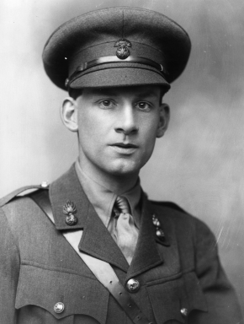

|  |  |
| --- | --- |
| **Name:** | Siegfried Sassoon |
| **Date of Birth:** | 8th September 1886 |
| **From:** | Weirleigh, near Paddock Wood in Kent |
| **Education:** | Marlborough School, then Clare College Cambridge University. |
| **Served with:** | Sassoon enlisted as a cavalry trooper in the Sussex Yeomanry  He then became an officer in the Royal Fusiliers. |
| **Rank:** | Company Commander |
| **Where Served:** | The Somme, Palestine, St Floris |
| **Medals:** | The Military Cross |
| **Wounds:** | Lots of minor wounds, known as ‘Mad Jack’ for the risks he would take.  Spent some time in Craiglockhart Hospital while the authorities decided what to do with him when he protested against the war, where he met Wilfred Owen. A head wound at St Floris. |
| **Date of Death:** | 1967 |
| **Some Poems Written:** | How to Die, The General, The Hero |
| **Style of Poetry:** | Sharply against the war and the people in charge, a satiric edge. |

|  |  |
| --- | --- |
| **Name:** | Wilfred Owen |
| **Date of Birth:** | 18th March 1893 |
| **From:** | Plas Wilmot, Oswestry |
| **Education:** | Birkenhead Institute and at Shrewsbury Technical School |
| **Served with:** | Enlisted in 3/28th London Regiment  Then commissioned into Manchester Regiment and served with both the 2nd and 5th Battalion. |
| **Rank:** | Lieutenant |
| **Where Served:** | The Somme, Serre, Beaurevoir-Fonsomme Line, Sambre-Oise Canel |
| **Medals:** | The Military Cross |
| **Wounds:** | Concussion at the Somme  Shell Shock, stayed at Craiglockhart Hospital where he met Sassoon |
| **Date of Death:** | 4th November 1918 |
| **Some Poems Written:** | Disabled, Strange Meeting, Mental Cases |
| **Style of Poetry:** | Lyrical, longer poems that protest against the war by highlighting the soldiers’ conditions. |

**Research Task**

On the previous page, you have discovered the basic facts about the two most famous First World War poets. However, there were lots of poets who were equally well known and important.

Your task is for your group of three or four to present your research about your chosen poet to the class. You can either do this orally using a poster you have made or using PowerPoint.

Remember: don’t copy chunks of text from the Internet onto a PowerPoint presentation. This must be your work, the Internet is a tool for information and PowerPoint is a presentation and prompt tool. The words you write and say:

***MUST BE YOUR OWN!***

**Poets:**

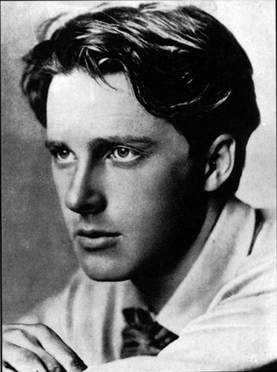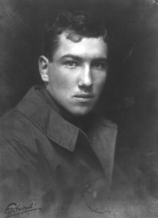

* Rupert Brooke
* Robert Graves
* Edward Thomas
* Isaac Rosenberg
* Ivor Gurney
* Jessie Pope
* Margaret Postgate-Cole

You must fill in a grid for your poet, like the ones made for Wilfred Owen and Siegfried Sassoon (obviously, if the person didn’t serve in the army, you can find out other information instead).

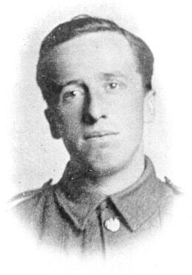

You can also find a picture of the person, a cover of a book of their poetry and you could read out one of their poems to the class.

The following web sites below are useful:

http://www.firstworldwar.com/poetsandprose/

http://www.spartacus.schoolnet.co.uk/

http://www.oucs.ox.ac.uk/ltg/projects/jtap/tutorials/intro/

**In Flanders Fields**

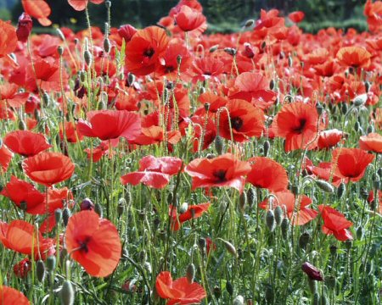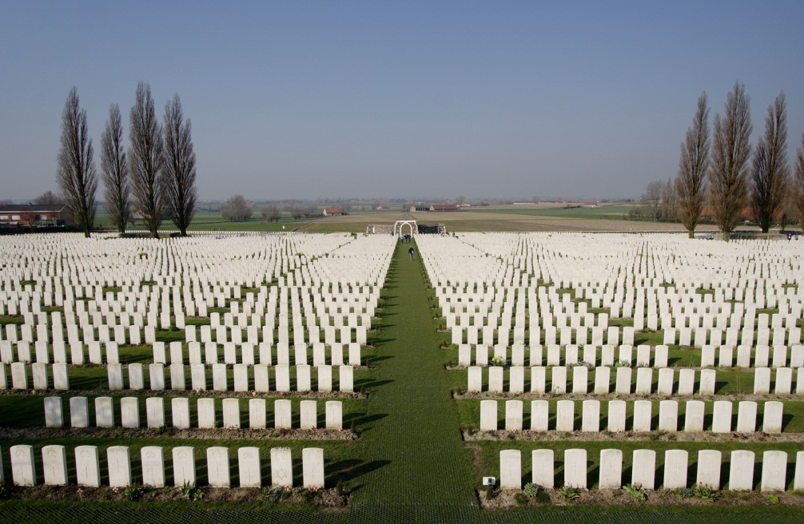

In Flanders fields the poppies blow   
Between the crosses, row on row,   
That mark our place; and in the sky   
The larks, still bravely singing, fly   
Scarce heard amid the guns below.

We are the Dead. Short days ago   
We lived, felt dawn, saw sunset glow,   
Loved and were loved, and now we lie,   
In Flanders fields.

Take up our quarrel with the foe:   
To you from failing hands we throw   
The torch; be yours to hold it high.   
If ye break faith with us who die   
We shall not sleep, though poppies grow   
In Flanders fields.

***~ John McRae***

**Questions.**

1. Compare the mood in the first two stanzas with that in the third.
2. Is this a pro-war poem? If so why; if not, why not?
3. Who is the speaker in this poem?
4. What does the speaker want his listeners to do?
5. What do crosses mark “row on row” marking a place refer to? What is in the sky? What is heard below?
6. What happened “short days ago”? Have you thought of those that lived in the past this way before?
7. What is being tossed to us? Is this a “torch” you can touch? If not, to what is the author referring?
8. Explain what the following quote might mean: “If ye break-faith with us who die.” Compare/contrast this with this quote from the bible, from John 15:13, “Greater love hath no man than this, that a man lay down his life for his friends.”

**Dulce et Decorum est**

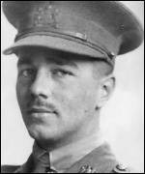

**Bent double, like old beggars under sacks,**

**Knock-kneed, coughing like hags, we cursed through sludge,**

**Till on the haunting flares we turned our backs**

**And towards our distant rest began to trudge.**

**Men marched asleep. Many had lost their boots**

**But limped on, blood-shod. All went lame, all blind;**

**Drunk with fatigue; deaf even to the hoots**

**Of tired, outstripped Five-Nines that dropped behind.**

**Gas! GAS! Quick, boys! – An ecstasy of fumbling,**

**Fitting the clumsy helmets just in time;**

**But someone still was yelling out and stumbling,**

**And flound’ring like a man in fire or lime…**

**Dim, through the misty panes and thick green light,**

**As under a green sea, I saw him drowning.**

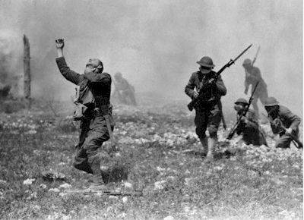

**In all my dreams, before my helpless sight,**

**He plunges at me, guttering, choking, drowning.**

**If in some smothering dreams you too could pace**

**Behind the wagon that we flung him in,**

**And watch the white eyes writhing in his face,**

**His hanging face, like a devil’s sick of sin;**

**If you could hear, at every jolt, the blood**

**Come gargling from the froth-corrupted lungs,**

**Obscene as cancer, bitter as the cud**

**Of vile, incurable sores on innocent tongues, -**

**My friend, you would not tell with such high zest**

**To children ardent for some desperate glory,**

**The old Lie: Dulce et decorum est**

**Pro patria mori.**

***~ Wilfred Owen***

**Analysing the Poem “Dulce et Decorum est”**

1. What is the title of this poem?

**First Stanza:**

1. What is the main emotion expressed in the first stanza (verse)?
2. Write an example of a simile used in the first stanza:
3. Where were the ‘haunting flares’ coming from?
4. Describe what the soldiers looked and felt like as they marched away from the trenches:

**Second Stanza**:

1. How does the emotion change at the beginning of the second stanza?
2. What were the soldiers ‘fumbling’ for and why?
3. Write and explain the simile that Owen uses to describe how the soldier acted when he breathed in the gas:
4. Owen uses a metaphor to describe what the gas looked like. Write it and explain it here:

**Third Stanza:**

1. Why do you think the third stanza is only two lines long?

**Fourth Stanza:**

1. What is the main emotion expressed in the fourth stanza?
2. How does Owen describe the soldier’s face after he has been ‘flung in the wagon’?
3. Write two similes that Owen uses to describe how disgusting the effect of the gas is:
4. Name three parts of the body that are affected by this sort of gas:
5. What does the final line mean in English:

**Extension Question:** Write your opinion of this poem. Think about what the **emotion** expressed, use of **powerful words**, use of **similes and metaphors**, **layout**, and what the **poet is trying to say**. Try to use full sentences and give **reasons** to support your ideas:

**GLAD THAT I KILLED YER**

*Hear my voice; hearken unto my speech: for I have slain a man. — Genesis iv. 23.*

G

lad that I killed yer —

It was you or me:

Our bayonets locked,

And then I pulled mine free;

My heart beat like to burst;

But Gawd, I got in first-

Glad that I killed yer!

Glad that I killed yer,

Though you are so young:

How still you lie

With both your arms outflung:

There's red blood on your hair —

Well, what the Hell I care? —

Glad that I killed yer!

Glad that I killed yer —

You're my enemy;

I had to hate —

And you — you hated me;

You mightn't be to blame —

I killed yer just the same —

Glad that I killed yer!

**Questions:**

1. Describe how the poet’s mood changes throughout this poem.
2. What is the poet’s final thought on what happened? (see stanza 7)
3. What lasting effects will this moment have on the poet? (see stanza 5)
4. What line, which is repeated, suggests that he was simply lucky? (See stanza 1 & 7)
5. Do you think the poet was “Glad”?
6. Why does the poet use so much repetition?
7. Why does the poet use “yer” instead of you?

Glad that I killed yer —

That's the game o' war;

But for my luck

I'd lie just like you are;

Your blood is on my hand —

Surely you understand

I *had* to kill yer ?

Glad that I killed yer —

Yet I can't forget

The look you gave me

When we turned — and met —

Why do you follow me with staring eye?

Was it so difficult a thing to die —

Gawd! when *I* killed yer?

Glad that I killed yer—

Yet I'm sorry, too,

For those will wait

So long at home for you:

I have a mother living down at Bow —

Thank Gawd for this that yours will never know

'Twas I that killed yer!

Glad that I killed yer—

It was you or me:

It does seem strange,

But it had got to be.

My heart beat like to burst,

But Gawd, I got in first —

Glad that I killed yer!

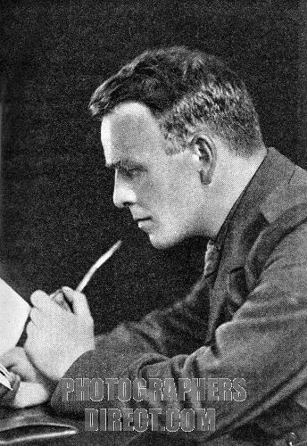

***~ Joseph Lee***



**Suicide in the Trenches**

I

**knew a simple soldier boy**

**Who grinned at life in empty joy,**

**Slept soundly through the lonesome dark,**

**And whistled early with the lark.**

**In winter trenches, cowed and glum,**

**With crumps and lice and lack of rum,**

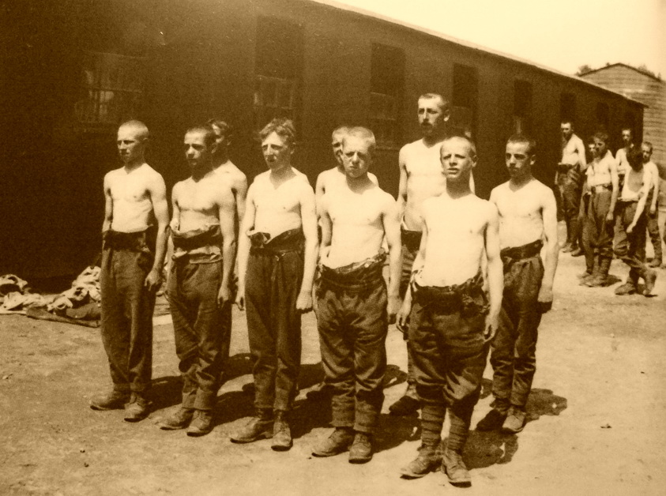

**He put a bullet through his brain.**

**No one spoke of him again.**

**\* * \***

**You smug-faced crowds with kindling eye**

**Who cheer when soldier lads march by,**

**Sneak home and prey you’ll never know**

**The hell where youth and laughter go.**

***~ Siegfried Sassoon***

**Questions:**

1. What kind of mood do you think Sassoon was in when he wrote this poem? Explain your answer.
2. Who does Sassoon direct his anger towards?
3. Was it a surprise that the soldier killed himself?
4. Why do you think that nobody spoke of the soldier again?

**Disabled by Wilfred Owen**



**He sat in a wheeled chair, waiting for dark,**

**And shivered in his ghastly suit of grey,**

**Legless, sewn short at elbow. Through the park**

**Voices of boys rang saddening like a hymn,**

**Voices of play and pleasure after day,**

**Till gathering sleep had mothered them from him.**

**\* * \***

**About this time Town used to swing so gay**

**When glow-lamps budded in the light blue trees,**

**And girls glanced lovelier as the air grew dim, -**

**In the old times, before he threw away his knees.**

**Now he will never feel again how slim**

**Girls' waists are, or how warm their subtle hands;**

**All of them touch him like some queer disease.**

**\* * \***

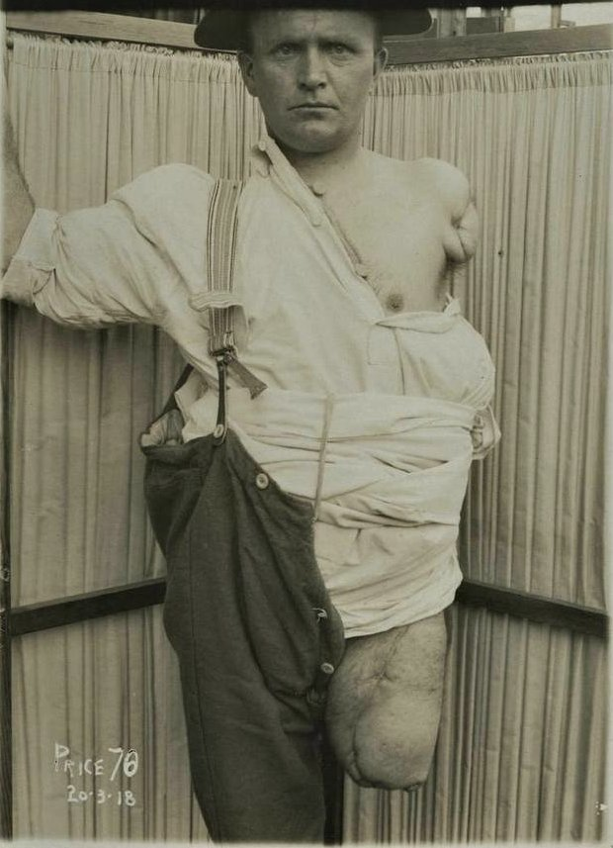

**There was an artist silly for his face,**

**For it was younger than his youth, last year.**

**Now, he is old; his back will never brace;**

**He's lost his colour very far from here,**

**Poured it down shell-holes till the veins ran dry,**

**And half his lifetime lapsed in the hot race**

**And leap of purple spurted from his thigh.**

**\* * \***

**One time he liked a blood-smear down his leg,**

**After the matches, carried shoulder-high.**

**It was after football, when he'd drunk a peg,**

**He thought he'd better join. - He wonders why.**

**Someone had said he'd look a god in kilts,**

**That's why; and may be, too, to please his Meg;**

**Aye, that was it, to please the giddy jilts**

**He asked to join. He didn't have to beg;**

**Smiling they wrote his lie; aged nineteen years.**

**Germans he scarcely thought of; all their guilt,**

**And Austria's, did not move him. And no fears**

**Of Fear came yet. He thought of jewelled hilts**

**For daggers in plaid socks; of smart salutes;**

Questions

1. What was life like for the soldier before he joined up? Use evidence from the text.
2. Why did he join up?
3. What happened to him?
4. Where is he now?
5. What is his life like now?
6. How is he treated by the nurses? Give evidence from the text.
7. What does the future hold for him?
8. What is the tone of the poem?
9. Why do you think Owen wrote this poem?

**And care of arms; and leave; and pay arrears;**

**Esprit de corps; and hints for young recruits.**

**And soon, he was drafted out with drums and cheers.**

**\* * \***

**Some cheered him home, but not as crowds cheer a Goal.**

**Only a solemn man who brought him fruits**

**Thanked him; and then inquired about his soul.**

**\* * \***

**Now, he will spend a few sick years in institutes,**

**And do what things the rules consider wise,**

**And take whatever pity they may dole.**

**\* * \***

**To-night he noticed how the women's eyes**

**Passed from him to the strong men that were whole.**

**How cold and late it is! Why don't they come**

**And put him into bed? Why don't they come?**

**Poetry Comparison**

You are going to write an essay comparing two poems, ‘Dulce et Decorum est3 and a poem of your choice from the anthology which you have studied. To do this, you should have annotated the poems, highlighting language devices and their effect.

Compare the two poems in both theme (what it’s about) and style (how it’s written). Using the grid below, look at the similarities and differences between the two poems:

|  |  |  |
| --- | --- | --- |
| **Things To Look For** | **Dulce et Decorum est** |  |
| Themes |  |  |
| Form and structure |  |  |
| Poetic voice |  |  |
| Intended audience |  |  |
| Rhythm |  |  |
| Rhyme |  |  |
| Diction |  |  |
| Imagery |  |  |
| Sound effects |  |  |
| Tone of Poem |  |  |
| Message |  |  |

**Essay Plan**

**Compare and contrast the ways that the writers of two poems, ‘Dulce et Decorum est’ by Wilfred Owen, and one other poem from the anthology, convey the horror of war.**

**Introduction**

Explain which poems you are comparing / contrasting. Briefly explain the ‘stories’ of each poem in turn and say whether you think the poets successfully convey the horror to the reader.

**Main Section**

This is where you discuss the differences and similarities between the poems. The best way to do this is to compare them both throughout the main body of the essay rather than analyse one poem and then the other. Remember that you are looking at the ways that the poet has developed their point of view and passed this message on to the reader. You should be discussing the following things in relation to the poems:

**Themes**

**Poetic voice**

**Rhythm**

**Rhyme**

**Diction**

**Imagery**

**Sound devices**

**Tone**

**Conclusion**

This is where you want to make some final comments to finish off your essay, but you want to leave the reader with your final thoughts, these are the ones that they will be left with after they have finished reading your essay. Try to:

* Draw in a point that you have mentioned in your introduction,
* Try to add something further from your introduction to show progress in your discussions,
* Avoid using phrases such as, ‘in conclusion’ or ‘to sum up’, they are over-used and have become clichés.

**Remember:**

* Point
* Example
* Explanation
* Effect
* Link

**Success Criteria**

**Remember - Tick list for success**

1. PEEEL throughout your essay - :o) Make a Point, provide Evidence (best to use quotes), Explain what is shown or revealed by it, explain the Effect this has on the reader and Link the point to the next paragraph.
2. Quote!
3. Any quotes you include must be written in quotation marks “……” even if it is only one word.
4. The title of the poem also goes into quotation marks ‘ ’.
5. Do not write things such as “A quote which shows this is…” or “I know this because it says…” - they sound really immature! If you are stuck as to how to introduce the quote then the best thing to do is just write it out and explain why it backs up your point!!
6. Refer to the poet as their second or full name, not their first name! They are not your mates!
7. Do not write out huge passages from the poems. Choose your quotes carefully and ensure that they are no longer than two or three lines, max!